Sample Astrophysics Paper Template for HyperScience Intonational Journal

John A. Smith¹ , Maria B. Lee² , David K. Kumar³

1. Department of Physics, Stellar University, USA
2. Institute of Exoplanetary Science, Europa Research Center
3. Astrophysics Division, Galaxy Institute, UK
john.smith@stellaruni.edu
maria.lee@erc.eu
david.kumar@galinst.ac.uk

ABSTRACT
The abstract should not exceed 250 words and must be written as a single paragraph. It provides a concise yet comprehensive summary of the paper, clearly stating the purpose and motivation of the research, briefly outlining the methodology or approaches employed, and presenting the principal results in quantitative terms wherever possible. The abstract should also highlight the broader significance and implications of the findings while maintaining clarity and brevity. References, figures, tables, and undefined abbreviations must not be included. Because the abstract is often the only section read by reviewers, indexers, and readers scanning search results, it must be fully self-contained and precise.

KEYWORDS: Exoplanets; Orbital Resonance; Astrophysics; IEEE Style; Simulation.

INTRODUCTION
The introduction should begin by providing the background and context of the research work. Authors must explain the broader scientific field to which the study belongs, outline the current state of knowledge, and identify the specific gaps or unresolved problems that motivate the present investigation. A balanced review of relevant prior studies should be included, highlighting their contributions and limitations. For example, compact resonant planetary systems such as TRAPPIST-1 have been extensively studied, providing important insights into migration and long-term stability [1], while more recent observations of TOI-178 reveal complex resonant chains that challenge standard formation models [2]. Authors should ensure that the introduction gives readers a clear understanding of why the research problem is significant without going into excessive technical detail, which belongs in the methodology section.
In a separate paragraph, the authors must clearly state the aim and objectives of their work. This part should define the central research question or hypothesis and specify what the article sets out to accomplish. For example, the purpose of the paper may be to investigate the long-term dynamical stability of multi-resonant exoplanetary systems using fifth-order Runge–Kutta simulations, or to assess the influence of small perturbations in mass and eccentricity on resonance drift and quasi-chaotic behavior [3], [4]. Authors may also briefly describe the structure of the paper for reader orientation, such as: Section 2 describes the methodology, Section 3 presents the results, Section 4 discusses the implications, and Section 5 concludes the paper. When citing previous studies, references must follow IEEE numbering and be placed in square brackets, such as [1][2]

METHODOLOGY
The methodology section should clearly explain how the research was designed and conducted in sufficient detail to allow replication by other researchers. It must include a description of the theoretical framework, governing equations, or physical models used, along with the datasets, observational inputs, or experimental tools applied in the study. Authors are expected to describe the numerical techniques or algorithms in detail, specify all parameters and units, and explicitly state the assumptions or simplifications involved. The aim of this section is to provide transparency and reproducibility, ensuring that the reported results can be independently verified.
We employ N-body simulations using a fifth-order Runge–Kutta integrator to integrate the planetary equations of motion in a single-star gravitational potential. The stellar parameters are adopted from Gaia observations, and planetary initial conditions are based on NASA Exoplanet Archive data. [3, 4]

RESULTS AND DISCUSSION
The results and discussion section must present the findings of the study in a clear, logical, and structured manner. Authors should begin by describing the outcomes of their analysis or simulations, supported by figures, tables, and quantitative data. Each result must be explained in context, emphasizing its significance and connecting it to the research objectives stated in the introduction. Figures and tables must be high quality, properly labeled, and referred to directly in the text. Beyond reporting outcomes, authors are expected to interpret their results critically, comparing them with established theory or previous studies. This section should also include an evaluation of uncertainties, potential sources of error, and the robustness of the findings. A good discussion places the results within the broader context of astrophysics, showing how the work contributes to ongoing debates or opens new lines of inquiry.
Our simulations indicate that small perturbations in planetary mass and eccentricity can lead to resonance drift and quasi-chaotic behavior. Figure 1 and Figure 2 shows a sample orbital evolution schematic, while Table 1 and Table 2 also provides example stability metrics. These findings are consistent with analytical models of resonance overlap.[5]
Table 1. Example stability metrics for simulated planetary systems
Planet | Eccentricity | Stability Index
Planet b | 0.010 | 0.95
Planet c | 0.020 | 0.90
Planet d | 0.0005 | 0.8
Planet e | 0.07 | 0.6

Table 2. Resonant angle libration amplitudes (degrees)
Angle | Mean | Max
φ1 | 12.4 | 28.1
φ2 | 9.7 | 22.3

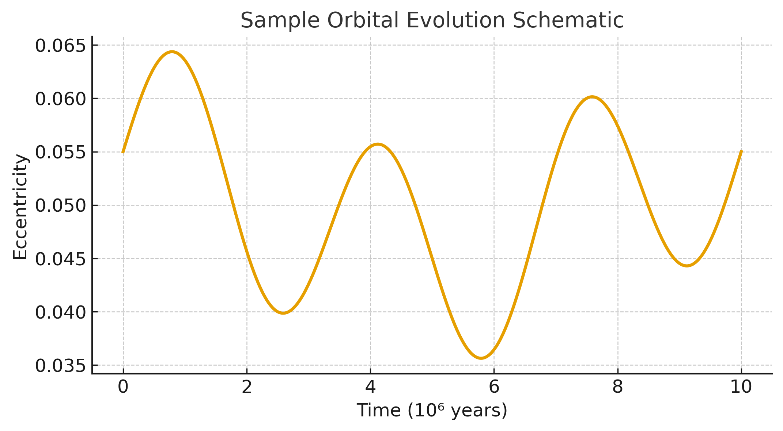
Fig. 1. Orbital evolution schematic for resonant exoplanets.

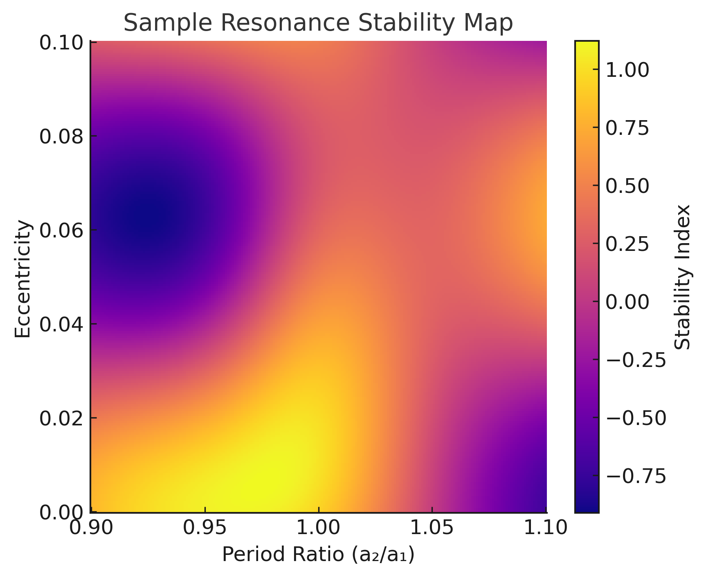
Fig. 2. Period ratio map highlighting resonance zones.

CONCLUSION
The conclusion must serve as a clear and concise synthesis of the entire study. Authors should begin by briefly restating the central problem or research question and summarizing how it was addressed. The key findings of the work must then be highlighted in a straightforward manner, avoiding repetition of all details presented in the Results and Discussion. Instead, the focus should be on the most significant outcomes and their direct scientific implications.
The conclusion should also emphasize the broader relevance of the study, explaining how the results advance knowledge in the field of astrophysics or related disciplines. If appropriate, authors may briefly acknowledge limitations of the study, but these should be stated in a constructive way that leads naturally to recommendations for future work. Suggestions for further research should be realistic, highlighting open questions, unexplored directions, or potential applications that arise from the current results.
Importantly, no new data, analyses, or figures should be introduced in the conclusion. The purpose of this section is to provide the reader with a final, well-balanced statement of what has been achieved, why it matters, and what steps may follow. A strong conclusion should leave the reader with a clear understanding of the paper’s main contributions and its place within the larger context of astrophysical research.
We presented a complete single-column Microsoft Word template aligned to IEEE-style references. The astrophysics example illustrates resonant exoplanet systems as a case study and demonstrates how to structure text, figures, tables, and citations for authors.

REFERENCES
[1] A. Leleu et al., “Resonant chains in exoplanetary systems,” A&A, vol. 688, A211, 2024. doi:10.1051/0004-6361/202450212
[2] L. Delrez et al., “TOI-178: Six planets in resonance,” A&A, vol. 667, A20, 2023.
[3] Gaia Collaboration, “Gaia Data Release 2,” A&A, vol. 616, A1, 2018.
[4] NASA Exoplanet Archive, [Online]. Available: https://exoplanetarchive.ipac.caltech.edu
[5] J. Wisdom, “Resonance overlap and onset of chaos in planetary systems,” AJ, vol. 128, pp. 484–490, 2004.

